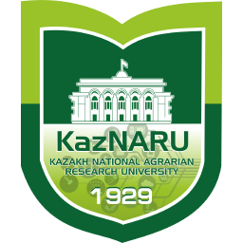 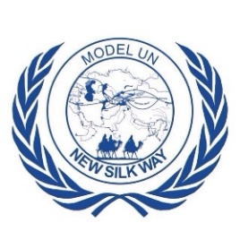 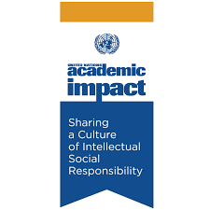 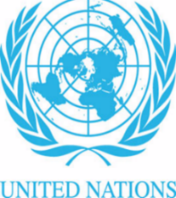 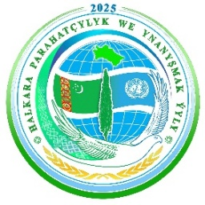 

**KazNARU Model UN 2025**

**Location:** **KazNaru university**

**Abay Avenue, 8g/7a / Kanysha Satpayev Street, 8g/7a**

**Almaty, Kazakhstan**

**Time: February 22, 2025, 9 a.m.**

We are thrilled to invite you to one of the most exciting events of the year — KazNARU Model UN, dedicated to anniversary of Kazakhstan’s accession to the United Nations.

**Schedule**

|  |  |
| --- | --- |
| **Time: February 22, 2025, 9 a.m. Location:** **KazNaru university, Abay Avenue, 8** | |
| 9:00 – 10:00 | Registration of participants - Main building, 1st floor |
| 9:30 - 10:00 | Arrival of guests |
| 10:00-10:30 | Opening ceremony and Speeches of honorary guests  Moderator - Kristina Sveridyuk - Secretary General of Model UN KazNARU   |  |  | | --- | --- | | 1 | Rafis Abazov - Vice-Rector of the Kazakh National Agricultural Research University  Director of the Institute of Green and Sustainable Development, KazNARU | | 2 | Vlastimil Samek - Representative of the UN Department of Global Communications | | 3 | Nikita Shabayev - UN Volunteers Country Coordinator for Kazakhstan | | 4 | Nurymyrat Rozydzhumayev - Counselor of the Embassy Turkmenistan in Republic of Kazakhstan | | 5 | Gulmira Tulesbayeva – UNDP Project Manager | | 6 | Maiya Suyunchaliyeva - Deputy Director of the Institute of Green and Sustainable Development, KazNARU | |
| 10:30-11:00 | Cultural program |
| 11:00-11:20 | Official photo session |
| 11:20 – 11:40 | Delegates and participants disperse to their committees |
| 11:40-13.10 | **Beginning of the first committee session**  Roll call of simulation participants in each committee and Speech by delegates  RESPONSIBLE: COMMITTEE CHAIRMAN   1. ENG-Security Council(SC) Topic- The role of sanctions in the fight against violations of international law: an effective tool or a cause of global instability 2. ENG-UN Women Topic- Promoting women's leadership in politics: steps towards ensuring equality and participation of women in decision-making 3. Kaz-UNESCO Тақырып- Қақтығыс аймақтарындағы мәдени мұраны қорғау Қарулы қақтығыстар кезіндегі мәдени нысандарды қорғау тетіктері және оларды сақтаудың стратегиялары 4. Kaz-UN FAO Тақырып- Құрғақшылық және экстремалды ауа-райы жағдайында өнімділікті арттыру шешімдері 5. RUS-Security Council(SC) Тема- Регулирование гонки вооружений: путь к глобальной безопасности и предотвращению конфликта 6. ENG-UNGA Topic- Fighting Corruption: Strengthening Transparency and Fairness in Global Governance 7. RUS-UN Women Тема- Борьба с гендерной дискриминацией на рабочем месте: создание условий для равных возможностей и справедливости |
| 13:20-14:00 | Lunch break |
| 14:00-15:00 | **Session 2- Official debate** |
| 15:00-15:40 | Networking time |
| 15:50-17:00 | **Session 3- Writing a draft resolution**   1. ENG-Security Council(SC) Topic- The role of sanctions in the fight against violations of international law: an effective tool or a cause of global instability 2. ENG-UN Women Topic- Promoting women's leadership in politics: steps towards ensuring equality and participation of women in decision-making 3. Kaz-UNESCO Тақырып- Қақтығыс аймақтарындағы мәдени мұраны қорғау Қарулы қақтығыстар кезіндегі мәдени нысандарды қорғау тетіктері және оларды сақтаудың стратегиялары 4. Kaz-UN FAO Тақырып- Құрғақшылық және экстремалды ауа-райы жағдайында өнімділікті арттыру шешімдері 5. RUS-Security Council(SC) Тема- Регулирование гонки вооружений: путь к глобальной безопасности и предотвращению конфликта 6. ENG-UNGA Topic- Fighting Corruption: Strengthening Transparency and Fairness in Global Governance 7. RUS-UN Women Тема- Борьба с гендерной дискриминацией на рабочем месте: создание условий для равных возможностей и справедливости |
| 17:20-18:00 | Closing ceremony |